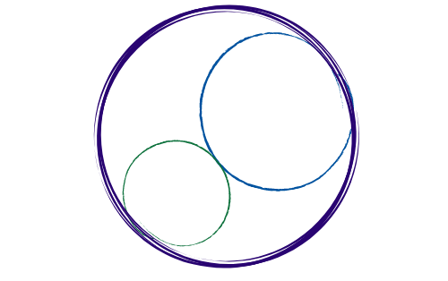October 3, 2025
12:00-2:30pm [SBTA Offices]

SBCCDTA
Amplifying the voices of fellow faculty to advocate for themselves by organizing and mentoring and defending and negotiating the contract.
Preliminary Items
12-12:20 pm
- Call to Order: noon

- Approval of Prior Minutes

- Approval of the Agenda

- CTA Report (New Executive Director Hire)

Action and Work Items
12:20-2:30 pm
The following items need discussion or action from the executive board.

- Bylaws Revisions Update (Sam/Meridyth)

- Elections/Voting Update (Micah)

- Grievance Update (Leonard)

- Proposition 55 Update (Maria/Micah/Antonio)

- Negotiations Update (Negotiations Team)

- Lecture/Lab Parity Update (Jessy/Jeff)
- Membership Update (Jeff)

- Luncheon Updates (CHC/SBVC)

- Escape Happy Hour Update (Meridyth)

- PT Equity Dinner Update (Karol)

- Treasury/UniServ Update (Read Report)

- Swag Order/Distribution Update (Read Report)

Membership

District-Wide

Position | Name | In Attendance
President | Jeff Demsky
Treasurer/Negotiations Lead | Jamie Salyer
Secretary | Maria Ortiz
PAC/Elections Chair | Micah Martin

Crafton Hills College

Position | Name | In Attendance
1st Vice President | Vacant
Full-time Rep #1 | Meridyth McClaren
Full-time Rep #2 | Robert McAtee
Part-time Rep | Karol McCool
Grievance | Leonard Lopez
Negotiations | Danielle Bell

Valley College

Position | Name | In Attendance
2nd Vice President | Denise Knight
Full-time Rep #1 | VACANT
Full-time Rep #2/Negotiations | Jessy Lemieux
Part-time Rep | Sam Valle
Negotiations | Suzi Mattson
Grievance | Leonard Lopez

Guests:

CTA Staff

_____________ ____________

Additional:

___________ _____________

___________ _____________

