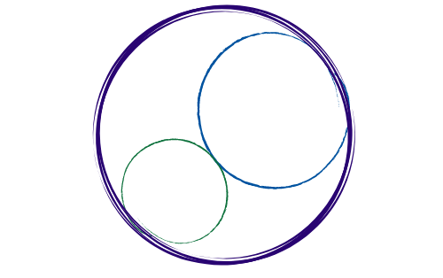November 7, 2025
12:00-3:00 pm [SBTA Offices]

SBCCDTA
Amplifying the voices of fellow faculty to advocate for themselves by organizing and mentoring and defending and negotiating the collective bargaining agreement.
Preliminary Items
12-12:20 pm
- Call to Order: noon

- Welcome Lisa Henkle (FT REP, SBVC)

- Approval of Prior Minutes

- Approval of the Agenda

- CTA Report (New Executive Director Connie Medina)

Action and Work Items
12:20-2:30 pm
The following items need discussion or action from the executive board.

- Treasurer’s Report (Jamie)

- Negotiations Update (Negotiations Team)

- Select January ’26 Plenary Location/Dates

- Reimbursement Form Process (Jamie)

- December E-Board Schedule (Jeff)
- Bylaws Revisions/Approval Vote (Sam)

- Standing Rules Update (Meridyth)

- FT REP CHC Voting Update (Micah)

- 2026 E-Board Elections (Jeff/Micah)

- Grievance Update (Leonard)

- Bowling Event/General Membership Meeting (Karol/Jeff)

- Swag Inventory/Distribution (Denise)

- PT Equity Dinner Update (Karol/Sam/Maria)

- PT Equity Dinner Stipend

- Proposed Stipend for PT Committee/Senate Service (Karol)

- Proposition 55 Update (Maria/Micah/Connie)

- Luncheon Update (CHC/SBVC)

Membership

District-Wide

Position | Name | In Attendance
President | Jeff Demsky
Treasurer/Negotiations Lead | Jamie Salyer
Secretary | Maria Ortiz
PAC/Elections Chair | Micah Martin

Crafton Hills College

Position | Name | In Attendance
1st Vice President | Meridyth McClaren
Full-time Rep #1 | VACANT
Full-time Rep #2 | Robert McAtee
Part-time Rep | Karol McCool
Grievance | Leonard Lopez
Negotiations | Danielle Bell

Valley College

Position | Name | In Attendance
2nd Vice President | Denise Knight
Full-time Rep #1 | Lisa Henkle
Full-time Rep #2/Negotiations | Jessy Lemieux
Part-time Rep | Sam Valle
Negotiations | Suzi Mattson
Grievance | Leonard Lopez

Guests:

CTA Staff

_____________ ____________

Additional:

___________ _____________

___________ _____________

