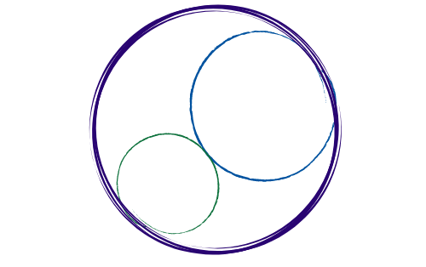May 2, 2025
12:00-2:30pm [SBTA Offices]

SBCCDTA
Amplifying the voices of fellow faculty to advocate for themselves by organizing and mentoring and defending and negotiating the contract.
Preliminary Items
12-12:20 pm
- Call to Order: noon

- Approval of Prior Minutes

- Approval of the Agenda

- CTA Report

Action and Work Items
12:20-2:30 pm
The following items need action from the executive board.

- TA Approval Debrief

- Online Voting Process Debrief

- SBTA/SBCCDTA Meeting Debrief

- CCA Spring Conference Debrief

- Elections Manual Update

- Bylaws Revision Update
- Standing Rules Update

- Picnic Planning Update

- CTA Ethnic Minority Early Identification Program Update

- CTA Institute for Teaching Grant Application Update

- Treasury/UniServ Update

- Negotiations Update

- Summer Plenary Update/Agenda Items

Summer CCA Conference Registration

- Upcoming CHC VP Vacancy/Special Election Process

- Proposition 55 Update

Membership

District-Wide

Position | Name | In Attendance
President | Jeff Demsky
Treasurer/Negotiations Lead | Jamie Salyer
Secretary | Maria Ortiz
PAC/Elections Chair | Micah Martin

Crafton Hills College

Position | Name | In Attendance
1st Vice President | Nick Reichert
Full-time Rep #1 | Meridyth McClaren
Full-time Rep #2 | Robert McAtee
Part-time Rep | Karol McCool
Grievance | VACANT
Negotiations | Danielle Bell

Valley College

Position | Name | In Attendance
2nd Vice President | Denise Knight
Full-time Rep #1 | Sheri Lillard
Full-time Rep #2/Negotiations | Jessy Lemieux
Part-time Rep | Sam Valle
Negotiations | Suzi Mattson
Grievance | Leonard Lopez

Guests:

CTA Staff

_____________ ____________

