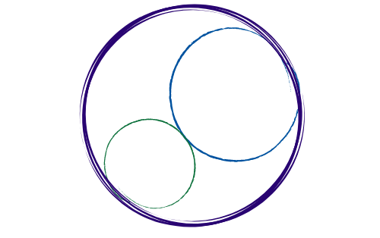November 15, 2025
General Membership Meeting
11am-noon [Empire Bowl, Redlands]

SBCCDTA
Amplifying the voices of fellow faculty to advocate for themselves by organizing and mentoring and defending and negotiating the contract.
Agenda Items
60 minutes

1. Presidential Update

2. Negotiations/TA Update

3. Grievance Processes

4. Online Voting Processes

5. Union Picnic Update

6. Bylaws/Standing Rules Update

7. Members’ Questions

